Chapter 3
Relational Database Design

1 Informal Design Guidelines for Relational Databases
1.1 Semantics of the Relation Attributes
1.2 Redundant Information in Tuples and Update Anomalies
1.3 Null Values in Tuples
1.4 Spurious Tuples
2 Functional Dependencies (FDs)
2.1 Definition of FD
2.2 Inference Rules for FDs
2.3 Equivalence of Sets of FDs
3 Normal Forms Based on Primary Keys
3.1 Introduction to Normalization
3.2 First Normal Form
3.3 Second Normal Form
3.4 Third Normal Form
4 General Normal Form Definitions (For Multiple Keys)
5 BCNF (Boyce-Codd Normal Form)

Informal Design Guidelines for Relational Databases

GUIDELINE 1: Informally, each tuple in a relation should represent one entity or relationship instance. (Apply to individual relations and their attributes).

• Attributes of different entities (EMPLOYEEs, DEPARTMENTs, PROJECTs) should not be mixed in the same relation

• Only foreign keys should be used to refer to other entities

• Entity and relationship attributes should be kept apart as much as possible.
Bottom Line: Design a schema that can be explained easily relation by relation. The semantics of attributes should be easy to interpret.

A Simplified Company Relational Schema
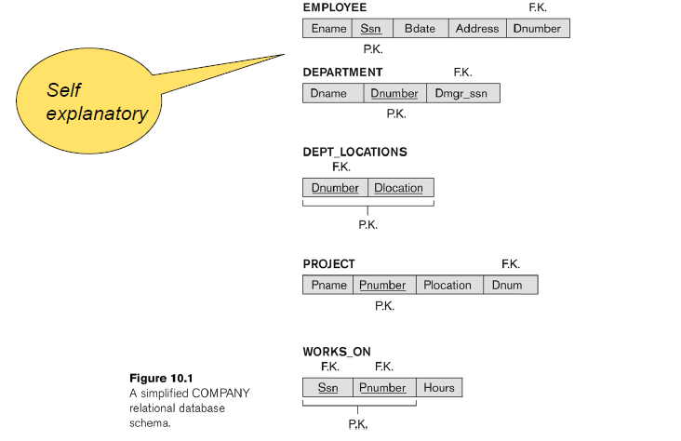

Redundant Information in Tuplesand Update Anomalies

- Big (and common) DB Problem:
In a poorly designed‘ DB information is stored redundantly
  - Consequences:
  - Wastes storage
  - Causes problems with update anomalies
Insertion anomalies
Deletion anomalies
Modification anomalies

EXAMPLE OF AN Update ANOMALY

Consider the relation:

EMP_PROJ(Emp#, Proj#, Ename, Pname, No_hours)

Update Anomaly:

Changing the name of project number P1 from “Billing” to "Customer-Accounting"may cause this update to be made for all 100 employees working on project P1.

EXAMPLE OF AN INSERT ANOMALY

Consider the relation:

EMP_PROJ (Emp#, Proj#, Ename, Pname, No_hours)

Insert Anomaly:

Cannot insert a project unless an employee is assigned to the project

Conversely

Cannot insert an employee unless an he/she is assigned to a project.

Figure of Two relation schemas suffering from update anomalies

Figure for Example State for and EMP_PROJ

GUIDELINE 2: Guideline to Redundant Information in and Update Anomalies
  - Design a schema that does not suffer from the insertion, deletion and update anomalies.

  - If there are any anomalies present, then note them so that applications can be made to take them into account.

GUIDELINE 3: Null Values in Tuples

- Relations should be designed such that their tuples will have as few NULL values as possible
- Attributes that are NULL frequently could be placed in separate relations (with the primary key)
Reasons for nulls:
  - Attribute not applicable or invalid
  - Attribute value unknown (may exist)
  - Value known to exist, but unavailable
Spurious Tuples
- Bad designs for a relational database may result in erroneous results for certain JOIN operations
- The "lossless join" property is used to guarantee meaningful results for join operations

GUIDELINE 4:
  - The relations should be designed to satisfy the lossless join condition.
  - No spurious tuples should be generated by doing a natural-join of any relations.
There are two important properties of decompositions:
a) Non-additive or losslessness of the corresponding join
b) Preservation of the functional dependencies.

Note that:
  - Property (a) is extremely important and cannot be sacrificed.

  - Property (b) is less stringent and may be sacrificed.
Example of Spurious Tuples

Example of Spurious Tuples

Functional Dependencies
- Functional dependencies (FDs) are used to specify formal measures of the "goodness" of relational designs
- FDs and keys are used to define normal forms for relations
- FDs are constraints that are derived from the meaning and interrelationships of the data attributes
- FD is a constraint between two sets of attributes
- A set of attributes X functionally determines a set of attributes Y if the value of X determines a unique value for Y
- X Y holds if whenever two tuples have the same value for X, they must have the same value for Y
- For any two tuples t1 and t2 in any relation instance r(R):
If t1[X]=t2[X],
then t1[Y]=t2[Y]
- X Y in R specifies a constraint on all relation instances r(R)
- Written as X Y; can be displayed graphically on a relation schema as in Figures. ( denoted by the arrow: ).
- FDs are derived from the real-world constraints on the attributes
Example

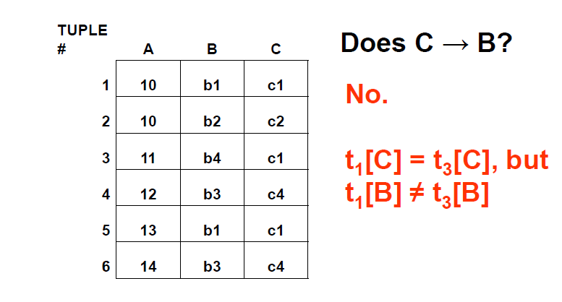
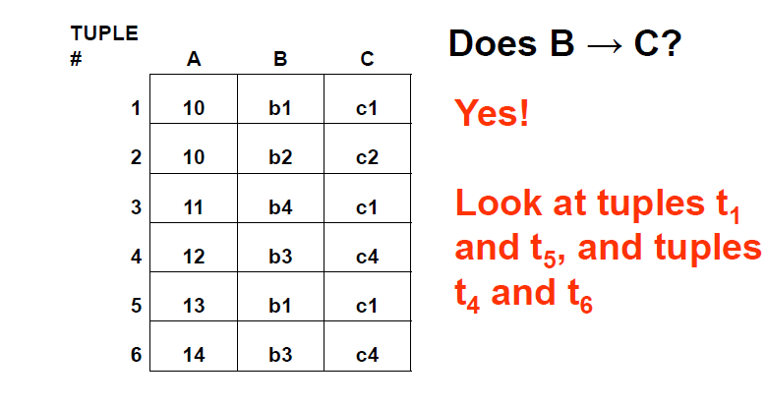
Examples of FD constraints
- social security number determines employee name SSN -> ENAME
- project number determines project name and location PNUMBER -> {PNAME, PLOCATION}
- employee ssn and project number determines the hours per week that the employee works on the project {SSN, PNUMBER} -> HOURS
- FDs must hold for all valid states of a relation, not just current state
- So define FDs carefully!
How do we identify FDs?
- Likely, some FDs will be obvious or identified in initial design of DB
- Vehicle(tagno, regstate, owner, make, model, year, gaseconomy, dealership, dealeraddr)
{tagno, regstate} → owner
{tagno, regstate} → {make, model, year}
{make, model, year} → gaseconomy,
dealership → dealeraddr etc…
- But the algorithms we use to test for other properties of good DB design often need to know ALL FDs!
- Some FDs may not be obvious, but can be deduced from other FDs
- Given a set of FDs F for a relation R, the set of all FDs for R is F⁺
(known as the closure of F)

Inferring FDs
Ex: (SSN, PNUMBER, HOURS, ENAME, PNAME, PLOCATION)
SSN → ENAME,
{SSN, PNUMBER} → HOURS, PNUMBER → PNAME, PNUMBER → PLOCATION
PNUMBER → PNAME,
so {PNUMBER, HOURS} → PNAME
PNUMBER → PNAME and PNUMBER → PLOCATION, so PNUMBER → {PNAME, PLOCATION}
Inference Rules for FDs
Given a set of FDs F, we can infer additional FDs that hold whenever the FDs in F hold
Armstrong's inference rules:
IR1. (Reflexive) If Y subset-of X, then X -> Y
IR2. (Augmentation) If X -> Y, then XZ -> YZ (Notation: XZ stands for X U Z)
IR3. (Transitive) If X -> Y and Y -> Z, then X -> Z
IR1, IR2, IR3 form a sound and complete set of inference rules
Some additional inference rules that are useful:
(Decomposition) If X -> YZ, then X -> Y and X -> Z
(Union) If X -> Y and X -> Z, then X -> YZ
(Psuedo-transitivity) If X -> Y and WY -> Z, then WX -> Z
- The last three inference rules, as well as any other inference rules, can be deduced from IR1, IR2, and IR3 (completeness property)
Inference Rules for FDs
- Closure of a set F of FDs is the set F⁺ of all FDs that can be inferred from F
- Closure of a set of attributes X with respect to F is the set X ⁺ of all attributes that are functionally determined by X
- X ⁺ can be calculated by repeatedly applying IR1, IR2, IR3 using the FDs in F
Closure of X under F (X⁺)
- X⁺ = set of all attributes dependent on X
- Algorithm
  - start with X⁺ = X
  - for each FD Y → Z in F do
if Y is a subset of X⁺ then X⁺ = X⁺ U Z
- Continue this process until no more attributes can be added to X⁺

Example
Given a relation Student and a set of functional dependencies F as follows, compute the closure for all LHS.
Student(SID, dept, dept_chair)
F = { SID → {dept, dept_chair}, dept → dept_chair,
{SID, dept} → dept_chair }
{SID}⁺ = {SID, dept, dept_chair}
{dept}⁺ = {dept, dept_chair}
{SID, dept} ⁺ = {SID, dept, dept_chair}
If the closure of a LHS includes all attributes, then this LHS is a super key of the relation.
Candidate Keys
- If X⁺ contains all attributes in a relation R, and if there does not exist Y in X
such that (X – Y)⁺ = all attributes in R, then X is a candidate key for R
- In previous example, {SID,dept}⁺ includes all attributes, SID⁺ also includes all attributes.
- SID is a candidate key
Exercise
R(A,B,C,D,G,H)
F = { A → B, B → C, CD → H, BC →G}
- What is the closure of AC?
Minimal Sets of FDs
- A set of FDs is minimal if it satisfies the following conditions:
- Every dependency in F has a single attribute for its RHS.
- We cannot remove any dependency from F and have a set of dependencies that is equivalent to F.
- We cannot replace any dependency X -> A in F with a dependency Y -> A, where Y proper-subset-of X ( Y subset-of X) and still have a set of dependencies that is equivalent to F.
- Every set of FDs has an equivalent minimal set
- There can be several equivalent minimal sets
- There is no simple algorithm for computing a minimal set of FDs that is equivalent to a set F of FDs

Algorithm
Given a set of FDs F, find its minimal cover
- Step1: Decompose each FD to get single attribute at RHS
- Step2: For each FD, remove redundant attribute from LHS
- Step3: Remove redundant FDs
Example
Given F= {B → AB, D → A, AB → D}
- Step 1: B → AB is decomposed into B → A, B → B
(B → B is trivial and is removed)
- Step 2: check if AB → D has redundant LHS. Can it be A → D or B → D?
Compute AB⁺, A⁺, B⁺ based on F
AB⁺ = ABD and B⁺ = ABD, so A is extraneous.
- So far, we have F= {B → A, D → A, B → D}
- So far, we have F= {B → A, D → A, B → D}
- Step 3: check if there is any redundant FDs. Is B → A redundant?
Compute B⁺ based on F- {B → A}
B⁺ = BDA, that means we can obtain
B → A from F- {B → A} so B → A is redundant.
Similarly, check the remaining FDs.
Final answer F’ = {D → A, B → D}
Exercise
Given a set of FDs F, find its minimal cover
- Step1: Decompose each FD to get single attribute at RHS
- Step2: For each FD, remove redundant attribute from LHS
- Step3: Remove redundant FDs

Question: what is the minimal cover of F?
R(A, B, C), F = {A → B, BC → A, AB → AC}

Minimal Set (Cover) of FDs
- There can be more than one minimal cover for a relation
- They won’t necessarily have the same number of FDs

Normalization of Relations
- Normalization: The process of decomposing unsatisfactory "bad" relations by breaking up their attributes into smaller relations
- Normal form: Condition using keys and FDs of a relation to certify whether a relation schema is in a particular normal form
- 2NF, 3NF, BCNF
  - based on keys and FDs of a relation schema
  - 4NF
  - based on keys, multi-valued dependencies : MVDs; 5NF based on keys,
- Join dependencies : JDs (Chapter 11)
- Additional properties may be needed to ensure a good relational design (lossless join, dependency preservation; Chapter 11)
Practical Use of Normal Forms
- Normalization is carried out in practice so that the resulting designs are of high quality and meet the desirable properties
- The practical utility of these normal forms is questionable when the constraints on which they are based are hard to understand or to detect
- The database designers need not normalize to the highest possible normal form
  - (usually up to 3NF, BCNF or 4NF)
- Denormalization:
  - The process of storing the join of higher normal form relations as a base relation—which is in a lower normal form
Definitions of Keys and Attributes Participating in Keys
- A superkey of a relation schema R = {A1, A2, ...., An} is a set of attributes S subset-of R with the property that no two tuples t1 and t2 in any legal relation state r of R will have t1[S] = t2[S]
- A key K is a superkey with the additional property that removal of any attribute from K will cause K not to be a super key any more.
- If a relation schema has more than one key, each is called a candidate key.
  - One of the candidate keys is arbitrarily designated to be the primary key, and the others are called secondary keys.
  - A Prime attribute must be a member of some candidate key
- A Nonprime attribute is not a prime attribute—that is, it is not a member of any candidate key.

First Normal Form 1NF
- A relation scheme R is in first normal form (1NF) if the values in dom (A) are atomic for every attribute A in R.
- Disallows
  - composite attributes
  - Set-valued attributes
  - nested relations; a cell of an individual tuple is a complex relation

Normalization nested relations into 1NF

Second Normal Form
- Uses the concepts of FDs, primary key
- Definitions
  - Prime attribute: An attribute that is member of the primary key K
  - Left-Reduced or Full functional dependency: a FD Y Z where removal of any attribute from Y means the FD does not hold any more
- Examples:
  - {SSN, PNUMBER} HOURS is a full FD since neither SSN " HOURS nor PNUMBER HOURS hold
  - {SSN, PNUMBER} ENAME is not a full FD (it is called a partial dependency ) since SSN ENAME also holds

- A relation scheme R is in second normal form (2NF) with respect to a set of FDs F if it is in 1NF and every nonprime attribute is fully dependent on every key of R.
- R can be decomposed into 2NF relations via the process of 2NF normalization
- Example
Let R=ABCD and F = { AB → C, B → D }. Here AB is a key. C and D are non-prime. C is fully dependent on the entire key AB, however D functionally depends on just part of the key (B →D). This is called a partial dependency

Third Normal Form
Definition:
Given a relation scheme R, a subset X of R, an attribute A in R, and a set of FDs F, A is transitively dependent upon X in R if there is a subset Y of R with:
X Y, YX and Y A under F and AϵXY.

Examples:
Schema (ABCD) and F = {A B, B AC, C D }
D is transitively dependent on A(and B) via C, however C is not transitively dependent on A via B (B is prime).
- A relation schema R is in third normal form (3NF) if it is in 2NF and no non-prime attribute A in R is transitively dependent on the primary key
- R can be decomposed into 3NF relations via the process of 3NF normalization
- NOTE:
  - In X Y and Y Z, with X as the primary key, we consider this a problem only if Y is not a candidate key.
  - When Y is a candidate key, there is no problem with the transitive dependency .
  - E.g., Consider EMP (SSN, Emp#, Salary ).
- Here, SSN Emp# Salary and Emp# is a candidate key.
Normalizing into 2NF and 3NF

Normal Forms Defined Informally
- 1st normal form
  - All attributes depend on the key
- 2nd normal form
  - All attributes depend on the whole key
- 3rd normal form
  - All attributes depend on nothing but the key
General Normal Form Definitions
- The above definitions consider the primary key only
- The following more general definitions take into account relations with multiple candidate keys
- A relation schema R is in second normal form (2NF) if every non-prime attribute A in R is fully functionally dependent on every key of R
- Example Consider the schema
- SUPPLIER(sname, saddress, item, iname, price) and FDs
- F= { sname saddress, item iname, {sname, item} price }
- {sname, item} is the primary key, all other attributes are non-prime.
- Observe that saddress depends on part of the key (sname).
- Likewise iname depends on part of the key (item)
- Therefore SUPPLIER is not in 2NF
- Definition:
  - Superkey of relation schema R - a set of attributes S of R that contains a key of R
- A relation schema R is in third normal form (3NF) if whenever a FD X A holds in R, then either:
  - X is a superkey of R, or
  - A is a prime attribute of R
- Consider an Example
- Example Key: { SID } and FD: SID→Building Building →Fee Building →Mgr
SID | Building | Fee | Manager
100 | Fenn | 300 | Mr. T
300 | ABC | 400 | Ali
200 | Holiday Inn | 400 | Tyson

Fee (and Manager) transitively depend on SID via the non-prime attribute Building. Therefore the relation is not in 3NF.
- Consider another Example
name | address | beer
Sally  Sally | 123 Maple  123 Maple | Bud  Miller
F= { name → address } Candidate key: (name, beer)
Is this relation in 3NF?
No: name is not a super key,
and address is not a part of any candidate key.
- Consider another Example
R(student, course, instructor) and F = {{student, course} → instructor, instructor → course}
Candidate key: (student, course)
It is in 3NF.

Is 3NF Good Enough?
- Still have data redundancy, consider following example
- student, course, instructor
(“John Doe”, “CS2300”, “McGeehan”)
(“Bob Jones”, “CS2300”, “McGeehan”)
This is Caused by the FD instructor → course where instructor is not a super key.
BCNF (Boyce-Codd Normal Form)
Definition
- A relation schema R is in Boyce-Codd Normal Form (BCNF) if whenever an FD XA holds in R, then X is a superkey of R
- Consider an Example
Keys: { {Sid Major}, {Sid Fname} }
Sid, Major Fname
Sid, Fname Major
Fname Major

SID | MAJOR | FNAME
100 | MATH | CAUCHY
100 | PHYL | PLATO
200 | MATH | CAUCHY
300 | PHYS | NEWTON
400 | PHYS | EINSTEIN

- The relation is in 3NF but not in BCNF. Observe that FnameMajor is valid, but Fname is not a superkey.
- Problem: Student 300 drops PHYS, We lose information that says NEWTON is a PHYS advisor
- A solution: Decompose the relation into two (SID, FNAME), (FNAME, MAJOR)
- Each normal form is strictly stronger than the previous one
  - Every 2NF relation is in 1NF
  - Every 3NF relation is in 2NF
  - Every BCNF relation is in 3NF
  - There exist relations that are in 3NF but not in BCNF
- The goal is to have each relation in BCNF (or 3NF)

Boyce-Codd Normal form

A relation TEACH that is in 3NF but not in BCNF

Achieving the BCNF by Decomposition
- Three possible decompositions for relation TEACH
  - {student, instructor} and {student, course}
  - {course, instructor } and {course, student}
  - {instructor, course } and {instructor, student}
- All three decompositions will lose FD { student, course} instructor
  - We have to settle for sacrificing the functional dependency preservation. But we cannot sacrifice the non-additivity property after decomposition.
- Out of the above three, only the 3rd decomposition will not generate spurious tuples after join.(and hence has the non-additivity property – to be discussed later) .

